**NETFLIX MOVIES AND TV SHOWS CLUSTERING**

**Saaquib Mustafa**

**Abstract**

Netflix is a company that manages a large collection of TV shows and movies, streaming it anytime via online. This business is profitable because users make a monthly payment to access the platform. However, customers can cancel their subscriptions at any time. Therefore, the company must keep the users hooked on the platform and not lose their interest. This is where recommendation systems start to play an important role, providing valuable suggestions to users is essential.

**Introduction**

**Netflix** is an American company that revolutionized the watching of movies and television shows. Established in 1997 in California by Reed Hastings (the current CEO)  and  Marc Randolph.  Netflix

offers film and  television  series  library through

distribution deals as well as its own productions, known  as  **Netflix  Originals**.  In  2007  Netflix

started subscription based streaming service that

allows  its  members  to  watch  TV  shows  and

movies on an internet connected device. Depending on our plan, we can also download TV shows and movies to our iOS, Android, or Windows 10

device and watch without an internet connectionThe movie and television library, and recommendation system  make accurate suggestion movie

to the customers and the convenience of access and relatively low price brought Netflix dominated position  in  the  market. They have over 8000

movies or tv shows available on their platform,

as of now, they

have over 200M subscribers globally and in 2021 they made $5.1 billion of net profit.

Netflix users value this platform for a wide offer, high quality  subtitles,   and,   yes,  accurate,

personalized recommendations. Netflix exploits

an   advanced   machine learning based

recommendation system that analyzes users’ choices to suggest them new movies and TV shows. In essence, it’s a set of algorithms using machine learning to analyze user data and movie ratings. To make it more effective, Netflix has set up 1,300 recommendation clusters based on users viewing preferences. As a result, whenever you turn on Netflix, you see a list of movies and TV shows tailored to your interests and user profile. The goal is to help each user find a movie or a TV show they will enjoy and do so as quickly as possible (estimations are they have just 90 seconds for that). The recommendation system itself remains in the back end and is invisible to the user.

**Problem Statement**

This dataset consists of tv shows and movies available on Netflix as of 2019. The dataset is collected from Flixable which is a third-party Netflix search engine.

In 2018, they released an interesting report which shows that the number of TV shows on Netflix has nearly tripled since 2010. The streaming service’s number of movies has decreased by more than 2,000 titles since 2010, while its number of TV shows has nearly tripled.

**In this project, you are required to do**

1. Exploratory Data Analysis
2. Understanding what type content is available in different countries
3. Is Netflix increasingly focused on TV rather than movies in recent years?
4. Clustering similar content by matching text-based features.

**Objective**

NetflixRecommender recommends Netflix movies and TV shows based on a user's favorite movie or TV show. It uses a Natural Language Processing (NLP) model and a K-Means Clustering model to make these recommendations. These models use information about movies and TV shows such as their plot descriptions and genres to make suggestions. The motivation behind this project is to develop a deeper understanding of recommender systems and create a model that can perform Clustering on comparable material by matching text-based attributes. Specifically, thinking about how Netflix create algorithms to tailor content based on user interests and behavior.

# **Data Description**

# **Attribute Information:**

The dataset provided contains 7787 rows and 12 columns.

The following are the columns in the dataset:

* **Show id:** Unique identifier of the record in the dataset
* **Type**: Whether it is a TV show or movie
* **Title:** Title of the show or movie
* **Director:** Director of the TV show or movie
* **Cast:** The cast of the movie or TV show
* **Country:** The list of the country in which a show/ movie is released or watched
* **Date added:** The date on which the content was onboarded on the Netflix platform
* **Release year:** Year of the release of the show/ movie
* **Rating:** The rating informs about the suitability of the content for a specific age group
* **Duration:** Duration is specified in terms of minutes for movies and in terms of the number of seasons in the case of TV shows
* **Listed in:** This columns species the category/ genre of the content
* **Description:** A short summary about the storyline of the content

**Approach**

As the problem statement says, understanding what type of content is available in different countries and Is Netflix increasingly focused on TV rather than movies in recent years we have to do clustering on similar content by matching text-based features. For that we used Affinity Propagation, Agglomerative Clustering, and K-means Clustering.

**Tools Used**

The whole project was done using python, in google Collaboratory. Following libraries were used for analyzing the data and visualizing it and to build the model to predict the Netflix clustering

* Pandas: Extensively used to load and wrangle with the dataset.
* Matplotlib: Used for visualization.
* Seaborn: Used for visualization.
* Nltk: It is a toolkit build for working with NLP.
* Datetime: Used for analyzing the date variable.
* Warnings: For filtering and ignoring the warnings.
* NumPy: For some math operations in predictions.
* Wordcloud: Visual representation of text data.
* Sklearn: For the purpose of analysis and prediction.

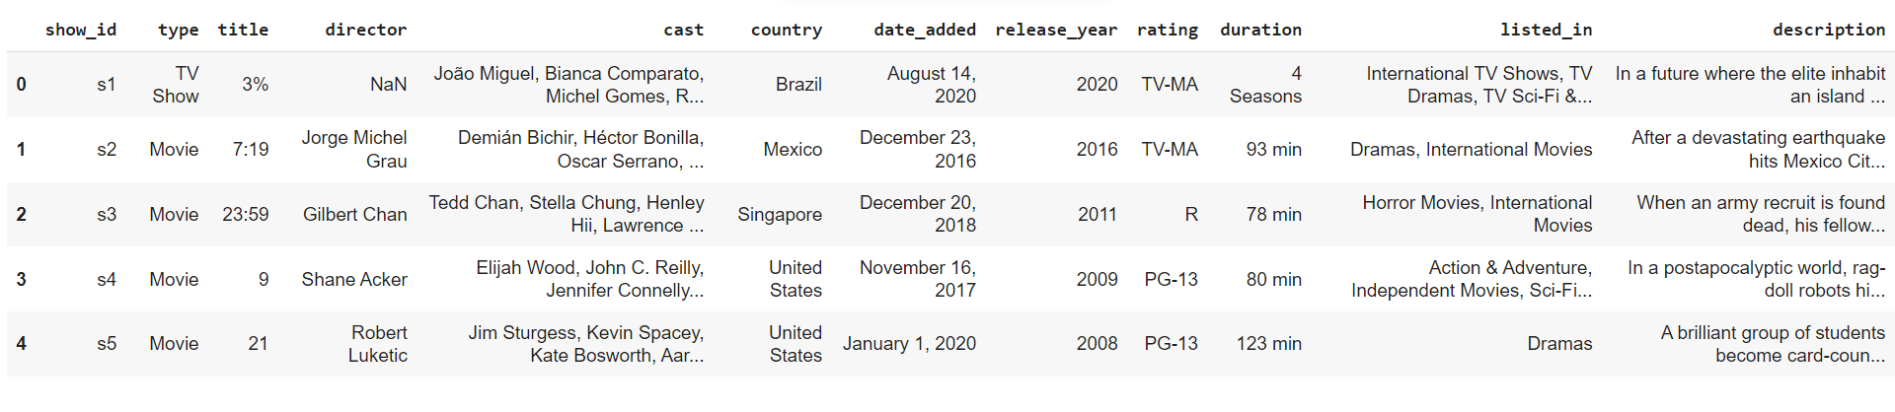**Table1*.*** *The above table shows the dataset in the form of Pandas Data Frame*

**Steps Involved**

The following steps are involved in the project

**1. Handling missing values:**

We will need to replace blank countries with the mode (most common) country. It would be better to keep director because it can be fascinating to look at a specific filmmaker's movie. As a result, we substitute the null values with the word 'unknown' for further analysis.

There are very few null entries in the date_added fields thus we delete them.

**2. Duplicate Values Treatment:**

Duplicate values dose not contribute anything to accuracy of results.

Our dataset dose not contains any duplicate values.

**Natural Language Processing (NLP) Model:**

For the NLP portion of this project, I will first convert all plot descriptions to word vectors so they can be processed by the NLP model. Then, the similarity between all word vectors will be calculated using cosine similarity (measures the angle between two vectors, resulting in a score

between -1 and 1, corresponding to complete opposites or perfectly similar vectors). Finally, I will extract the 5 movies or TV shows with the most similar plot description to a given movie or TV show.

**4. Exploratory Data Analysis**:

Exploratory Data Analysis (EDA) as the name suggests, is used to analyze and investigate datasets and summarize their main characteristics, often employing data visualization methods. It helps determine how best to manipulate data sources to get the answers you need, making it easier for data scientists to discover patterns, spot anomalies, test a hypothesis, or check assumptions. It also helps to understand the relationship between the variables (if any) and it will be useful for feature engineering. It helps to understand data well before making any assumptions, to identify obvious errors, as well as better understand patterns within data, detect outliers, anomalous events, find interesting relations among the variables.

After mounting our drive and fetching and reading the dataset given, we performed the Exploratory Data Analysis for it. To get the understanding of the data and how the content is distributed in the dataset, its type and details such as which countries are watching more and which type of content is in demand etc. has been analyzed in this step.

Explorations and visualizations are as follows:

1. Proportion of type of content
2. Country-wise count of content
3. Total release for last 10 years.
4. Type and Rating-wise content count
5. Top 10 genres in movie content
6. Length distribution of movies.
7. Season-wise distribution of TV shows.
8. Count of content appropriate for different ages.
9. Age-appropriate content count in top 10 countries with maximum content.
10. Proportion of movies and TV shows content appropriate for different ages.
11. Season wise distribution of TV shows.
12. Longest TV shows.
13. Top 10 topics on Netflix.
14. Extracting the features and creating the document term matrix.
15. Topic modeling using LDA and LSA.
16. Most important features of topic.

**5. Missing or Null value treatment:**

In datasets, missing values arise due to numerous reasons such as errors, or handling errors in data.

We checked for null values present in our data and the dataset contains a null value.

In order to handle the null values, some columns and some of the null values are dropped.

**6. Hypothesis from the data visualized:**

Hypothesis testing is done to confirm our observation about the population using sample data, within the desired error level. Through hypothesis testing, we can determine whether we have enough statistical evidence to conclude if the hypothesis about the population is true or not.

We have performed hypothesis testing to get the insights on duration of movies and content with respect to different variables.

**7. Tfidf vectorization:**

TF-IDF is an abbreviation for Term Frequency Inverse Document Frequency. This is a very common algorithm to transform text into a meaningful representation of numbers which is used to fit a machine learning algorithm for prediction.

We have also utilized the PCA because it can help us improve performance at a very low cost of model accuracy. Other benefits of PCA include reduction of noise in the data, feature selection (to a certain extent), and the ability to produce independent, uncorrelated features of the data.

So, it's essential to transform our text into tfidf vectorizer, then convert it into an array so that we can fit into our model.

* **Finding number of clusters**

The goal is to separate groups with similar characteristics and assign them to clusters.

We used the Elbow method and the Silhouette score to do so, and we have determined that 28 clusters should be an optimal number of clusters.

* **Fitting into model**

In this task, we have implemented a K means clustering algorithm. K-means is a technique for data clustering that may be used for unsupervised machine learning. It is capable of classifying unlabeled data into a predetermined number of clusters based on similarities (k).

**8. Data Preprocessing:**

**Removing Punctuation**: Punctuations does not carry any meaning in clustering, so removing punctuations helps to get rid of unhelpful parts of the data, or noise.

**Removing stop-words**: Stop-words are basically a set of commonly used words in any language, not just in English. If we remove the words that are very commonly used in a given language, we can focus on the important words instead.

**Stemming:** Stemming is the process of removing a part of a word, or reducing a word to its stem or root. Applying stemming to reduce words to their basic form or stem, which may or may not be a legitimate word in the language.

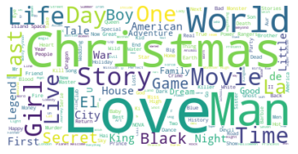

**9. Clustering:**

Clustering (also called cluster analysis) is a task of grouping similar instances into clusters. More formally, clustering is the task of grouping the population of unlabeled data points into clusters in a way that data points in the same cluster are more similar to each other than to data points in other clusters. The clustering task is probably the most important in unsupervised learning, since it has many applications.

for example:

**• Data analysis:** often a huge dataset contains several large clusters, analyzing which separately, you can come to interesting insights.

**• Anomaly detection:** as we saw before, data points located in the regions of low density can be considered as anomalies

**• Semi-supervised learning:** clustering approaches often helps you to automatically label partially labeled data for classification tasks.

**• Indirectly clustering tasks (tasks where clustering helps to gain good results):** recommender systems, search engines, etc.

• **Directly clustering tasks**: customer segmentation, image segmentation, etc.

**Building a clustering model:**

Clustering models allow you to categorize records into a certain number of clusters. This can help you identify natural groups in your data.

Clustering models focus on identifying groups of similar records and labeling the records according to the group to which they belong. This is done without the benefit of prior knowledge about the groups and their characteristics. In fact, you may not even know exactly how many groups to look for.

This is what distinguishes clustering models from the other machine-learning techniques—there is no predefined output or target field for the model to predict.

These models are often referred to as **unsupervised learning** models, since there is no external standard by which to judge the model's classification performance.

**10. Topic Modeling:**

**• Latent Semantic Analysis (LSA)**

LSA, which stands for Latent Semantic Analysis, is one of the foundational techniques used in topic modeling. The core idea is to take a matrix of documents and terms and try to decompose it into separate two matrices –• A document-topic matrix

• A topic-term matrix.

Therefore, the learning of LSA for latent topics includes matrix decomposition on the document-term matrix using Singular value decomposition. It is typically used as a dimension reduction or noise reducing technique.

**• Latent Dirichlet Allocation (LDA)**

LDA is a generative probabilistic model that assumes each topic is a mixture over an underlying set of words, and each document is a mixture of over a set of topic probabilities.

# **11. Clusters Model Implementation**

1. Silhouette score

2. Elbow Method

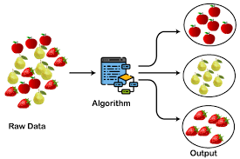

**1. Silhouette’s Coefficient**-

If the ground truth labels are not known, the evaluation must be performed utilizing the model itself. The Silhouette Coefficient is an example of such an evaluation, where a more increased Silhouette Coefficient score correlates to a model with better-defined clusters. The Silhouette Coefficient is determined for each sample and comprised of two scores

* Mean distance between the observation and all other data points in the same cluster. This distance can also be called a mean intra-cluster distance. The mean distance is denoted by a.
* Mean distance between the observation and all other data points of the next nearest cluster. This distance can also be called a mean nearest-cluster distance. The mean distance is denoted by b.The Silhouette Coefficient *s* for a single sample is then given as:

$$s=\frac{b-a}{max(a,b)}$$

Silhouette score is used to evaluate the quality of clusters created using clustering algorithms such as K-Means in terms of how well samples are clustered with other samples that are similar to each other. The Silhouette score is calculated for each sample of different clusters. To calculate the Silhouette score for each observation/data point, the following distances need to be found out for each observation belonging to all the clusters.

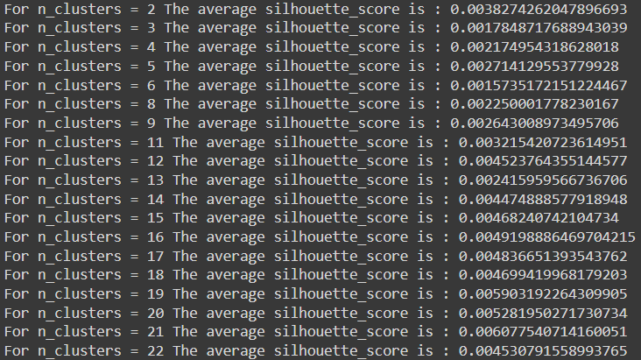

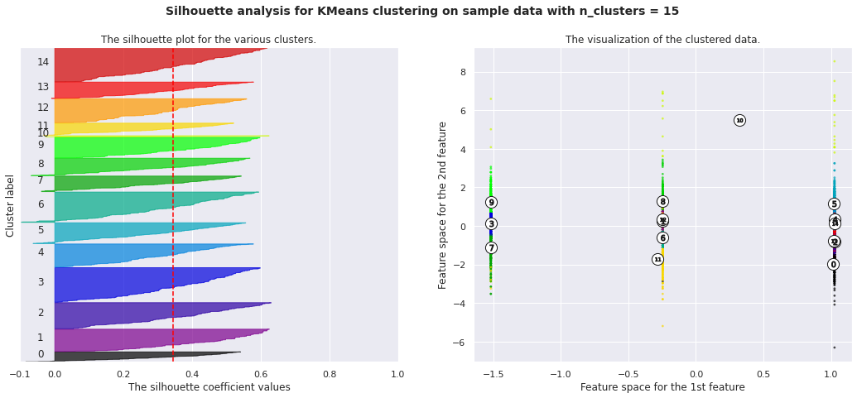

**2. Elbow Curve:**

The Elbow Curve is one of the most popular methods to determine this optimal value of k. The Elbow Method is a heuristic used in determining the number of clusters in a data set. The method consists of plotting the explained variation as a function of the number of clusters and picking the elbow of the curve as the number of clusters to use.

The elbow curve uses the sum of squared distance (SSE) to choose an ideal value of k based on the distance between the data points and their assigned clusters.

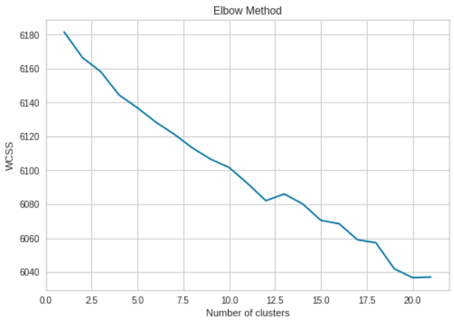

**Conclusion:**

The ratio of Tv show and movie is 31% to 69% in most watched-on Netflix

Here, top 20 Directors with the greatest number of Movies/Shows on Netflix. Highest is Raul Campos and lowest is Justin G. Dyck

The most of movies acted by any actor is Anupam kher followed by Takahiro and Shahrukh khan

Highest number in production, Tv shows and movies is in USA country followed by India.

Most movies/tv show got released in 2018 and least 2006

More content with Mature content is available on Netflix.

**Cluster value we got from kneeelbow method is 9**

* Cluster 0: Dramas & International TV Shows
* Cluster 1: Sc-Fi, Adventure and Action
* Cluster 2: International Movies
* Cluster 3: Comedy
* Cluster 4: Romantic Movies
* Cluster 5: Stand-Up Comedy
* Cluster 6: Documentary
* Cluster 7: International Movies
* Cluster 8: Children and Family movies